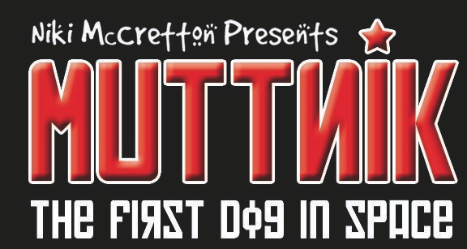
Technical Specification

If there are any technical queries please contact: Adam Hooper on 07734700022 or at hooperadam@hotmail.com

If there are any queries regarding the show please contact: claire@mortonbates.com or admin@aloadofstuffandnonsense.com

**Please note due to health and safety the company reserves the right to cancel if these conditions cannot be met. Please contact the company or Technical Manager immediately to discuss any concerns or questions.

- Minimum space 5m x 5m with a height of 3m. We are happy if the stage is larger. Please note for rural touring the space needs to allow room for the audience and technical operator outside of 5m x 5m.

- Flat, clean space preferably with a wooden floor covered in a black dance floor (grey will suffice).

- Under no circumstances can the floor be slippery (i.e. heavily varnished, parquet, polished etc) the show cannot be performed on a slippery floor.

- Space needs to be well ventilated and with adequate heating.

- Black backs (We’d love a star cloth if you have one!). We will need to tie an umbrella on elastic onto something high (grid would be fine) approx mid stage left which then needs to be masked.

- Space to be pre-rigged and focused (bar the specials). If you cannot pre-rig/focused please inform the company as soon as possible to arrange earlier access to the venue.

- We then require the space & a technician 2 hours before the house opens.

- We can strike the show in 30mins.

We travel with 2 large structures, which are wedge-shaped: 2080mm high, 1220mm deep & 2400mm on the diagonal. They do break down, but we will need extra time during the get-in to put them together again. Please inform us if you do not have access to accommodate these so that we can break them down prior to arrival.

The rest of the set consists of a chair & a dustbin in which all the props are carried.

We tour with a smoke machine, which needs to be operated from the control position. We require a 3 pin XLR lead from down stage left to that position (a mic tie line will be fine). A 13amp supply is also needed.

We require a good quality sound system. There must be speakers or monitors on the stage for the dancer.
We will need 2 CD players with auto pause

We require parking for a transit size van & possibly a car.

All our equipment is PAT tested and a risk assessment is available on request.

